Drupal 8: Drush & Console

1. Install drush9.
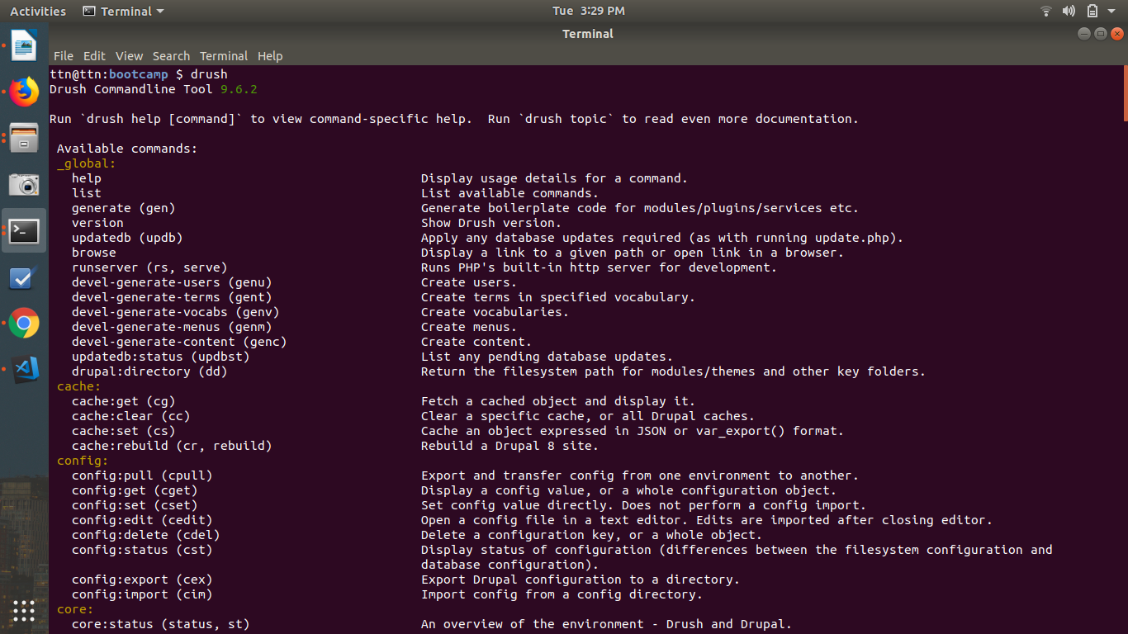
Command: composer require drush/drush
2. Install drupal console.
Command: composer require drupal/console
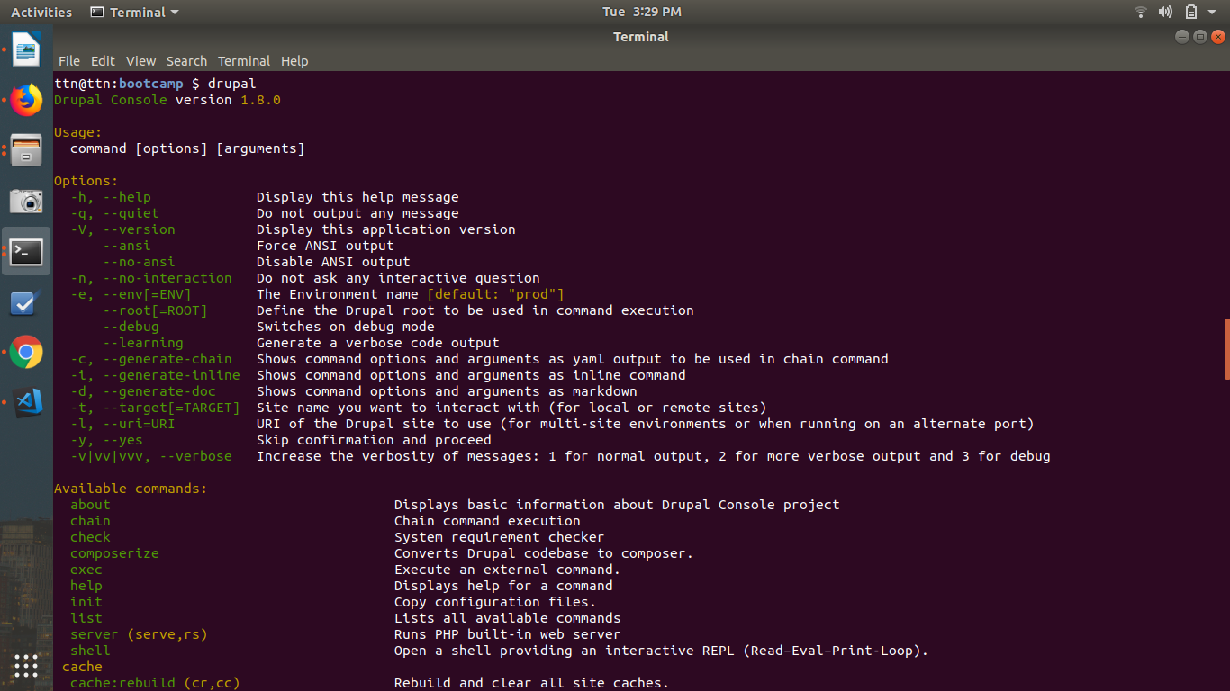
3. Create nodes for 2 diff content types using drupal console.
Command: drupal create:nodes / drupal crn
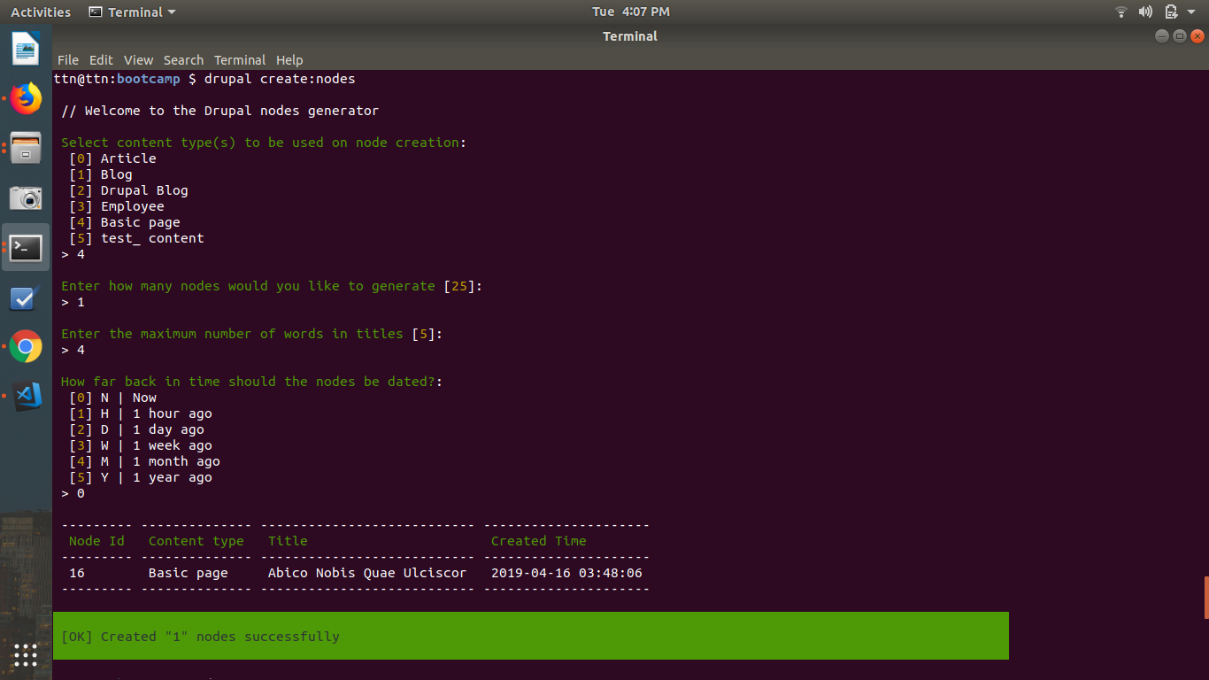
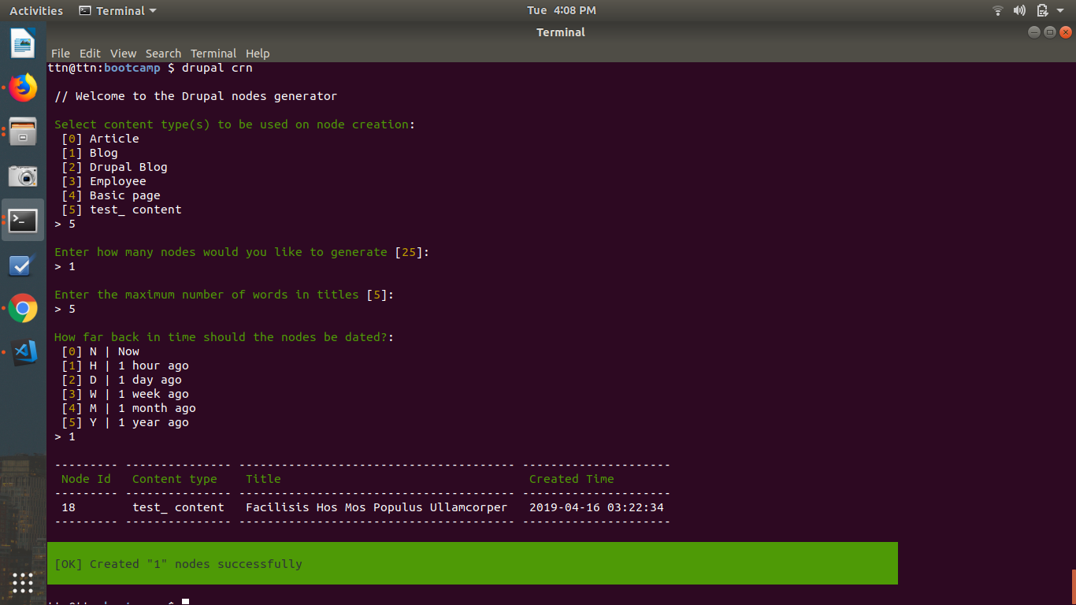

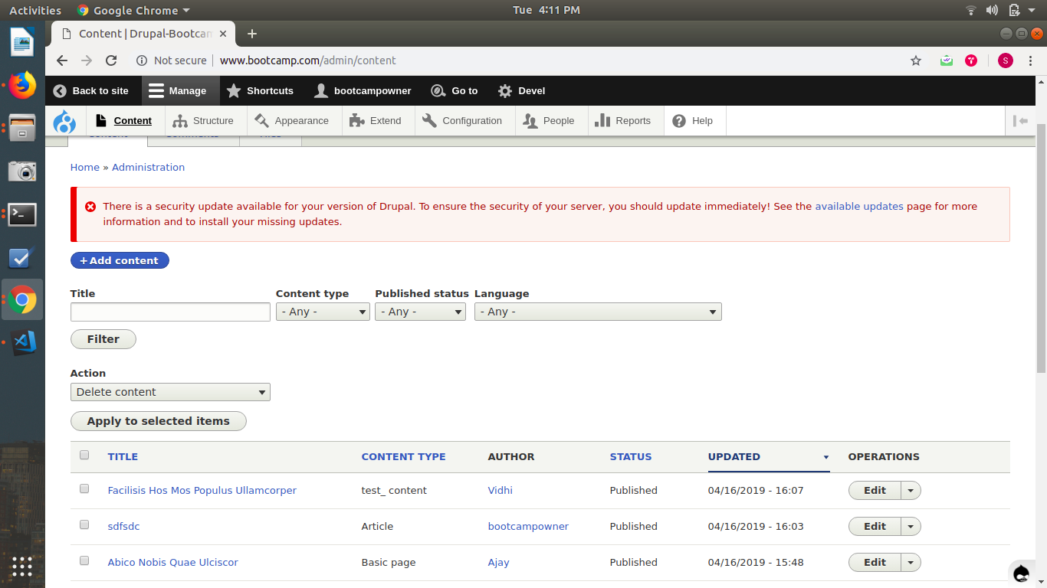
4. Create 2 roles and users for those roles using drupal console.
Command: drupal create:roles / drupal crr
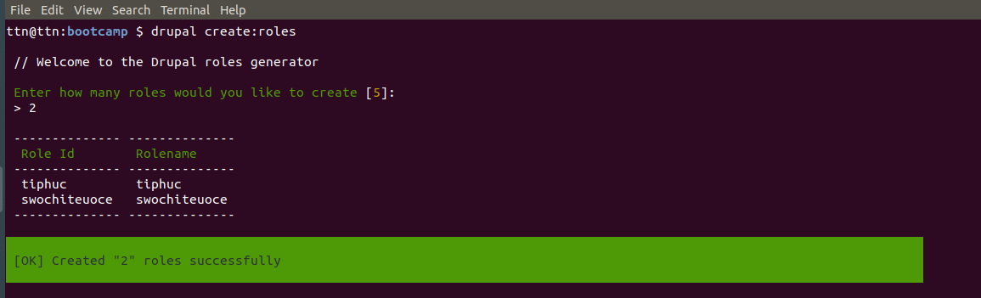
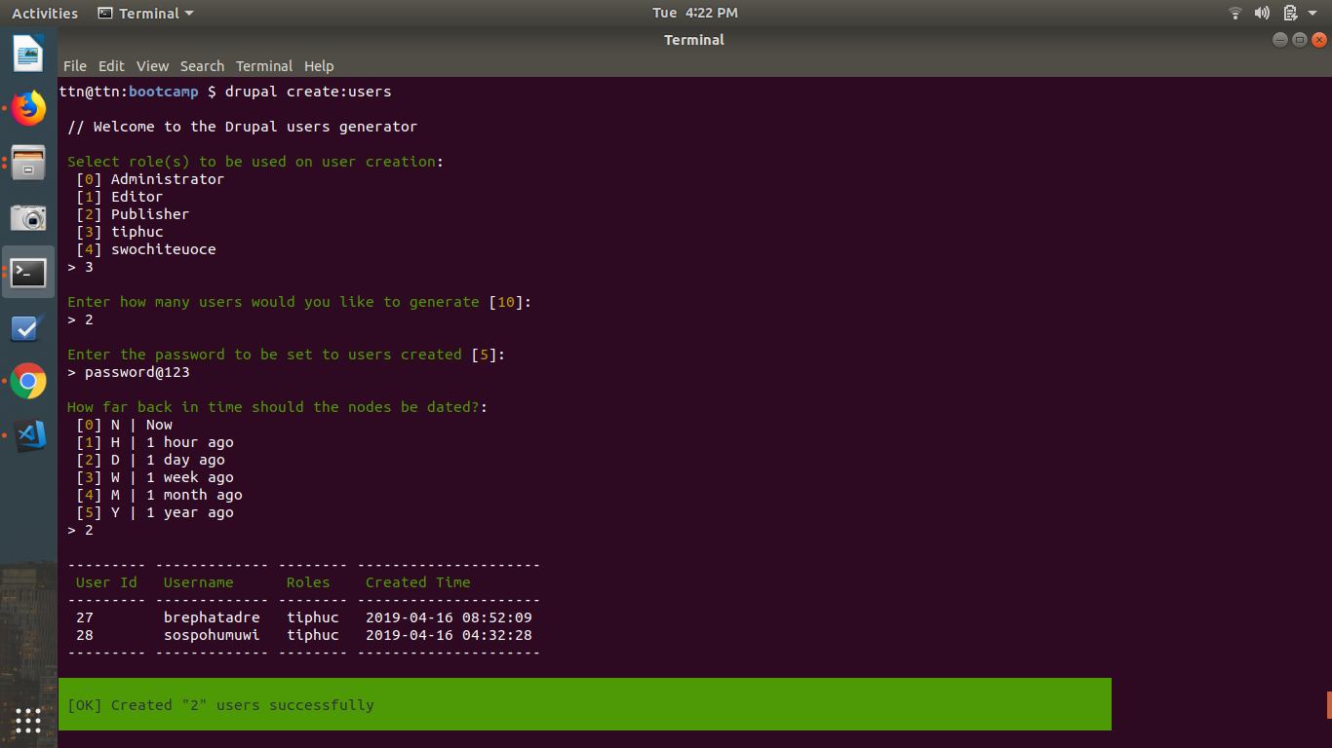

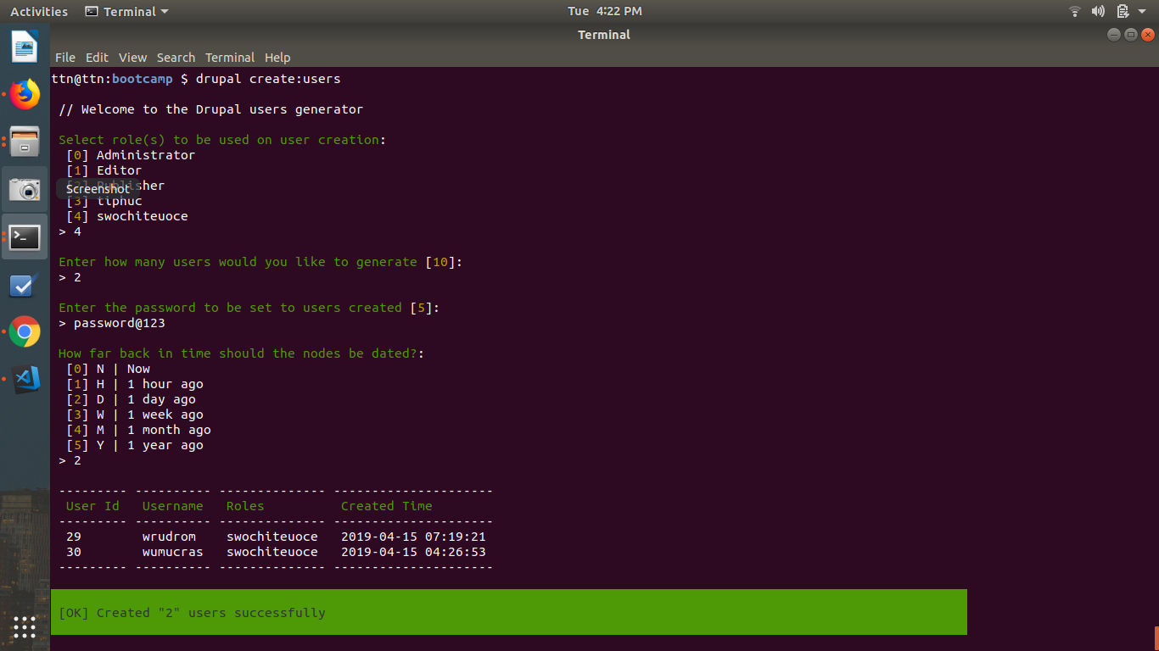

5. Create a module through drupal console.
Command: drupal generate:module / drupal gm
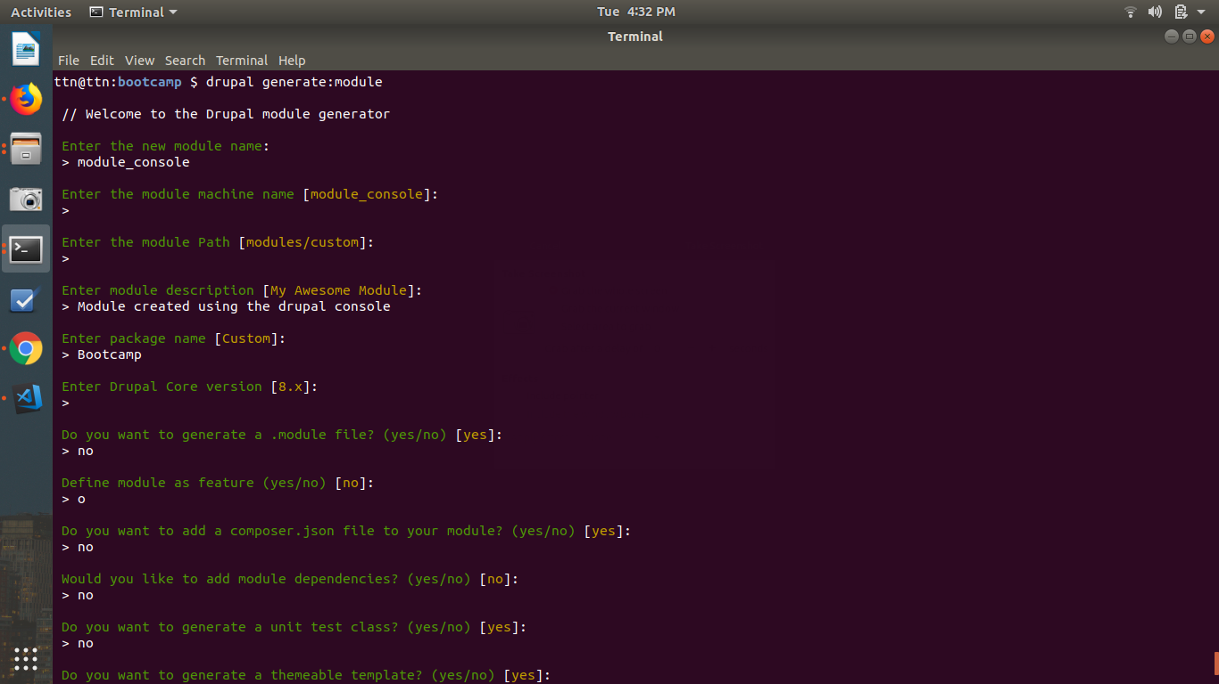
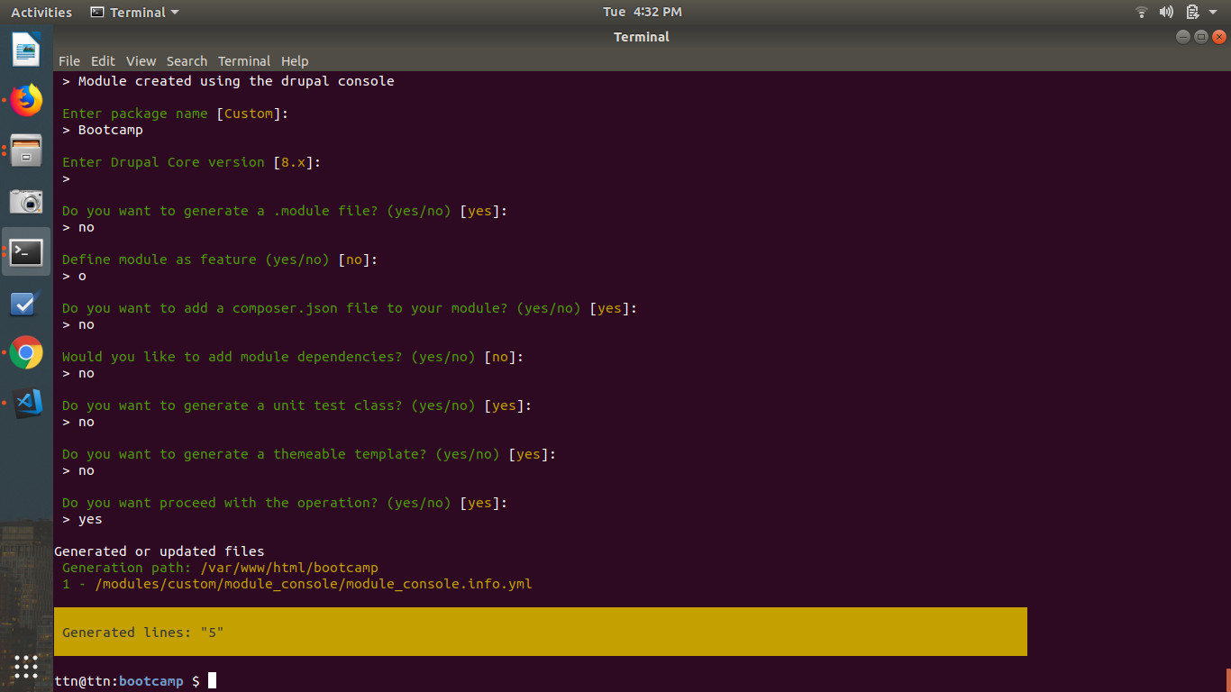

6. Create a custom drush command to ask user for a content type created in question 3 and display titles of its nodes.
Command: drush drush_command:node-title {name} / drush dc-nt {name}
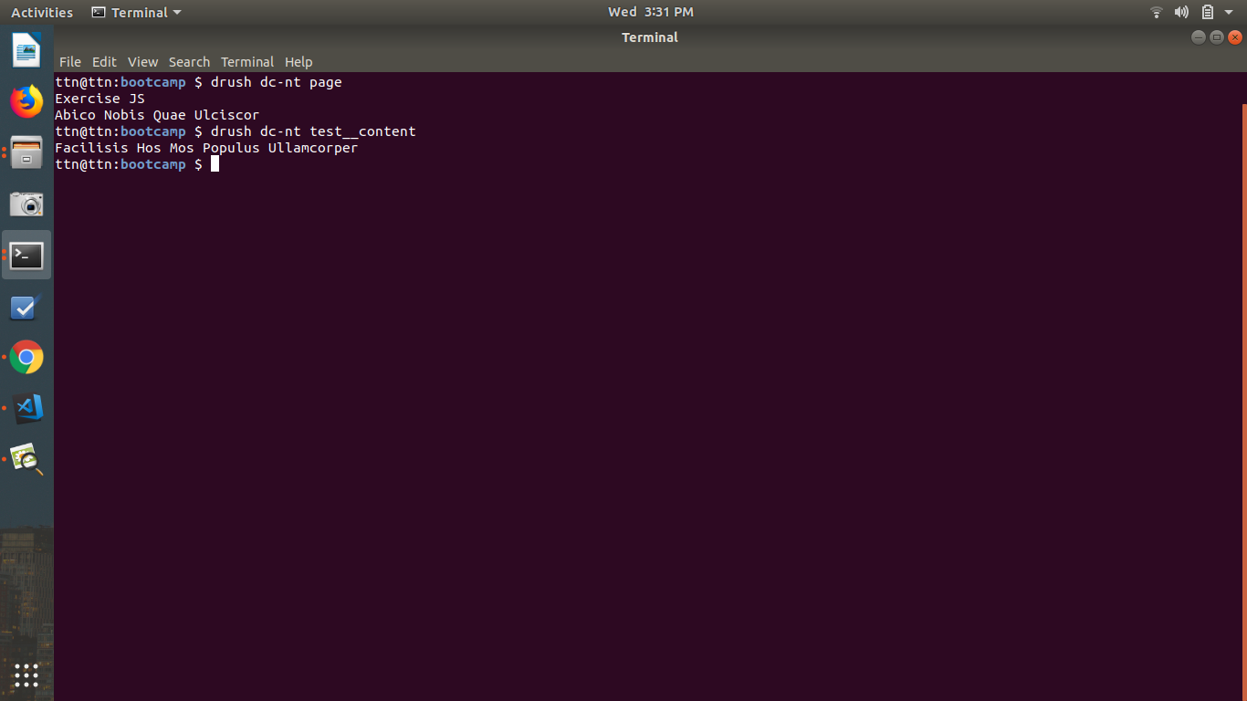
7. Create a custom drush command to ask user for a role created in question 4 and display email addresses of all the users belonging to that role.
Command: drush drush_command:user-email {role} / drush dc-ue {role}
